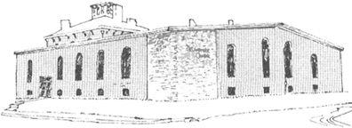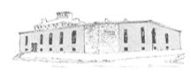

****

Pastor James Reynolds, Sr.

Asst. Pastor Stephen G. Reynolds, Sr.

1008 Congress St. Portland, ME 04102

Tel. (207) 774-8192

[www.**thedeliverancecenter**.com](http://www.thedeliverancecenter.com)

*From the Desk of Pastor Stephen Reynolds, Sr.*

To whom it may concern,

I am writing on behalf of Stephen Reynolds Jr. for his character is superb, He has performed in excellence in all of his duties here at the Deliverance Center. His faithfulness to his jobs that consist of working in the Deliverance Center Program for men, in the learning Center of Christian Academy of Portland, The Deliverance Bible Institute, Revival Crusades with Big Gospel Tent, Missionary work in Haiti and Tanzania Africa, evangelizing, Conventions, Adult Camp meetings, Youth retreats, Youth Camps, many field trips for inner city children, building churches, building schools, building houses, completing tax returns for many and performing all the Church office Work while helping residents, parishioners, other Workers and Teachers as an overwhelming example of humility and patience in the work place.

Stephen has proven skills that have been instrumental in keeping all these jobs going properly by reproducing excellence in other people’s lives and in my life and position as assistant Pastor of the Deliverance Center as well.

Quality control, Safety, Loyalty, Honesty, Commitment with an excellent spirit has always been shown in the most difficult times with multiple tasks.

Organizing, problem solving, networking, Computer trouble shooting, answering difficult phone calls, Editing, special touch in printing, engineering sound system in churches for regular services, special services, open air meetings and tent meetings, tent building of 50’ by 70’tent to 80’ by 105’ tent, working, supervising and always there when you need Him.

Many practical tasks have given Stephen the Experience that is absolutely necessary to guarantee the perfect product that is needed on time in this fast pace world.

Sincerely,

Stephen G. Reynolds, Sr.

Assistant Pastor